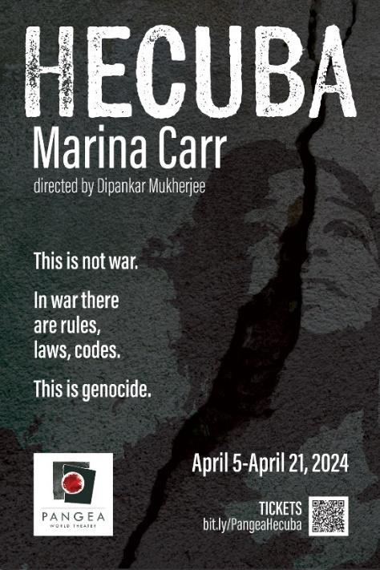

FOR IMMEDIATE RELEASE

MEDIA CONTACTS:
Sarah Duncan, Pangea World Theater Molly Steinke
sarah@pangeaworldtheater.org molly@nemerfieger.com
612.715.4134 612-309-1677

PANGEA WORLD THEATER PRESENTS:
“Hecuba”

April 5 - April 21 at The Southern Theater

MINNEAPOLIS (February 26, 2024) — Pangea World Theater presents “Hecuba” by Marina Carr, a compelling reimagining of the aftermath of the Fall of Troy, on stage at The Southern Theater April 5 – 21.

“Hecuba” follows Agamemnon, the victor, as he locks horns with Hecuba, the vanquished queen. Both have suffered intimate loss — the sacrifice of a daughter, and the murder of a son. In Marina Carr’s bold engagement with Euripides’ play of the same name written c. 424 BC (‘the most intensely tragic of all poets’ — Aristotle) there’s a demand for further bloodshed. In a brilliant display of ventriloquism, the drama weaves threads of inconsolable rage and grief with fate, revenge, and inevitable carnage. The show explores the shreds of duty and honor as well as the terrible deeds hatred breeds as it touches bravely on Hecuba’s heroic nature and ‘the endless tears of women’.

The “Hecuba” ensemble includes Suzanne Victoria Cross, Ankita Ashrit, Anne Guadagnino, Matthew Saxe, Ernest Briggs*,Tyler Stamm, J. Antonio Teodro, Neel Shah, Nathan Berglund, and Sudarsna Mukund.
* Actor Equity Association Membership

Director Dipankar Mukherjee’s artistic team features lighting design by Mike Grogan, set design by Orin Herfindal, costume design by Mary Ann Kelling, composition, live music and sound design by Bethany Lacktorin, assistant direction by Sir Curtis Kirby III, with stage management by Cassi Henning.

“As artists in Pangea, we are in search of understanding the complexity of the time we live in. Marina Carr’s adaptation of ‘Hecuba’ opens one portal to our current truth. Mythology holds many answers and many secrets. Myth is the repository of truths, both spoken and unspoken. It is up to us to learn from them. In our search for collective accountability, moments are marked when our conscience is put on trial, as during the current moment. This can be covered up with the dust of rhetoric, but the truth never fails to stare at our face. ‘Hecuba’ asks us — can we salvage our humanity when women and children’s bodies are weaponized in the name of war anywhere in the world?” said Pangea’s Artistic Director Dipankar Mukherjee.

Marina Carr is an Irish playwright who has written nearly 30 plays. She came to notoriety in the 1990s and is known for writing intense and often dark plays, and for being a particularly prolific and skillful voice in Irish drama. She often writes about human tragedy, and her work often takes its inspiration from classical texts. Carr was born in County Offaly to an artistic family and was educated at University College Dublin. In addition to Hecuba, her works include a take on Lorca's Blood Wedding, an adaptation of Anna Karenina, By the Bog of Cats, The Map of Argentina, Phaedra Backwards, Portia Coughlan, The Mai, Ullaloo, This Love Thing, and The Deer Surrender. Carr often writes about disturbing situations and unsympathetic characters. When a revival of her play On Raftery's Hill received backlash for depicting a scene of incestuous rape, Carr told The Guardian, "The moral police will be the death of art. Political correctness is destroying our literature and our poetry. There is a place for the moral high ground, but it is not art. You can't have the thought police looking over your shoulder when you are writing a play. You have to let the characters have their say. Plays are written with the imagination, not with the head." She has been Writer-in-Residence at Trinity College, the Abbey Theatre, Princeton University and was the first John McGahern Writer-in-Residence in St Patrick’s College, Drumcondra/DCU. Marina Carr is a member of Aosdána and lives with her family in Dublin.

‘I am not aware of another woman who writes about tragedy with such grandeur. She goes to a deep place that has not just to do with society now but that touches an inner tragedy of existence.’
— Joyce McMillen, New York Times

Dipankar Mukherjee is a professional director originally from Kolkata, India, with a 35+ year history of directing. He is the Artistic Director of Pangea World Theater, an international theater in Minneapolis that is a progressive space for arts and dialogue. As a director, he has worked in India, England, Canada, and the United States. Mukherjee has worked at the Guthrie Theater, Great Lakes Shakespeare Festival, New World Stages (NYC), Alliance Theatre (Atlanta), and at the Young Vic in London. His aesthetics have evolved through his commitment to social justice, equity, and deep spirituality and these factors, along with a response to relevant politics, forms the basis of his work. Mukherjee has been awarded the Twin Cities International Citizens Award by the Cities of Minneapolis and St. Paul for contributions in the area of human rights and international cooperation. He received the McKnight’s 2023 Distinguished Artist Award. He received a Humphrey Institute Fellowship to Salzburg, and has been a Ford Foundation delegate to India and Lebanon. He is a recipient of the Bush Leadership Fellowship award to study non-violence and peace methodologies in India and South Africa, and a Doris Duke Fellowship at Shangri-La. He also facilitates processes that disrupt colonial, racist, and patriarchal modalities of working and collaboratively searches for an alternate way of working.

“The violence lies in Carr’s language, shocking and extraordinarily vivid: we almost hear the buzzing of carrion flies, smell the stench of carnage.”
The Times ⭐⭐⭐⭐

“This is a play about persuasion and Carr has imbued the characters’ rhetoric with passion and a brisk immediacy”
The Evening Standard ⭐⭐⭐⭐

Hecuba "teases out the barbaric aftermath of the fall of Troy, while also presenting it as a metaphor for the modern day plight of those dispossessed by warfare – especially women and children."
The Stage ⭐⭐⭐⭐

“A beautiful, terrifying, almost uncannily eloquent play.”
The Independent ⭐⭐⭐⭐

Performances
The Southern Theater
1420 S Washington Ave, Minneapolis, MN 55454

Friday, April 5 @ 7:30 p.m.
Saturday, April 6 @ 7:30 p.m.
Sunday, April 7 @ 2:30 p.m., post-show discussion

Thursday, April 11 @ 7:30 p.m.
Friday, April 12 @ 7:30 p.m.
Saturday, April 13 @ 7:30 p.m.
Sunday, April 14 @ 2:30 p.m., ASL Interpretation, post-show discussion

Thursday, April 18 @ 7:30 p.m.
Friday, April 19 @ 7:30 p.m.
Saturday, April 20 @ 7:30 p.m.
Sunday, April 21 @ 2:30 p.m.

Tickets
General Admission: $18-35 (sliding scale)
Students: $15
Group rates available, contact Pangea for more information.

To reserve your seats, visit bit.ly/PangeaHecuba.

To learn more about this show, visit pangeaworldtheater.org.
This activity is made possible by the voters of Minnesota through a Minnesota State Arts Board Operating Support grant, thanks to a legislative appropriation from the arts and cultural heritage fund.

###

